Home Learning Pack (KS2) Week One
Space: This week’s topic is Space. We are going to learn about the planets in the solar system, the fitness and wellbeing of astronauts and the tests they have to do before going into space.
Activity | Resources | Potential Risks | Impact
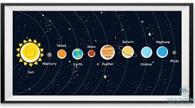  Planets in the Solar System | Pictures or cut outs of the planets in the Solar system as well and a picture of the Sun. | Make Sure you do this on a flat, even surface. | Children to understand the order of the planets in the solar system
Jump for the Moon  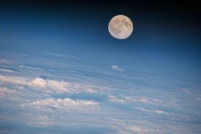 | Mission Journal  Pencil/Pen  Skipping ropes Stopwatch | Use a skipping rope appropriate for their height.  Bend their knees slightly when landing. Aim to land on the balls of their feet, then sink to their heels | Perform jump training with a rope, to increase bone strength  Perform jumps over markers or cones.  Record observations about improvements in their training in their Mission Journals.
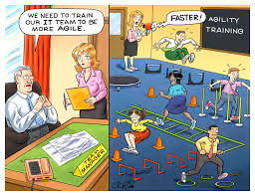  Astro Agility Course | 8 cones  Measuring tape or metre stick  Paper and pencil  Mission Journals  pencil  Stopwatch | Have suitable footwear on for this task. Do not do this barefoot for safety reasons | Tests agility and changing direction quickly.
Get on Your Space Bike, Scooter or Spacehopper (Mindfullness)  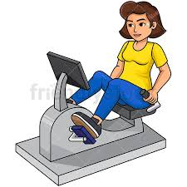 | Exercise Bicycle (if you have one)  Scooter  Space Hooper | Make sure you have appropriate footwear on. | Try to travel as far as they can on static exercise bikes. • Record the distance travelled and enter in your exercise diary
BUT FIRST…
YOGA/WELLBEING

Yoga is a system of physical exercises or postures. It builds strength, flexibility and confidence. Yoga is also about breathing, which helps calm and refresh the body and mind.
Sun Salutation is a simple yet powerful sequence you can do in a short amount of time. It stretches all the body and helps reduce stress. When the astronauts are in space, they will use Yoga exercises and stretches as a way of looking after own personal mental wellbeing. Please have a go at the movements in the diagram below
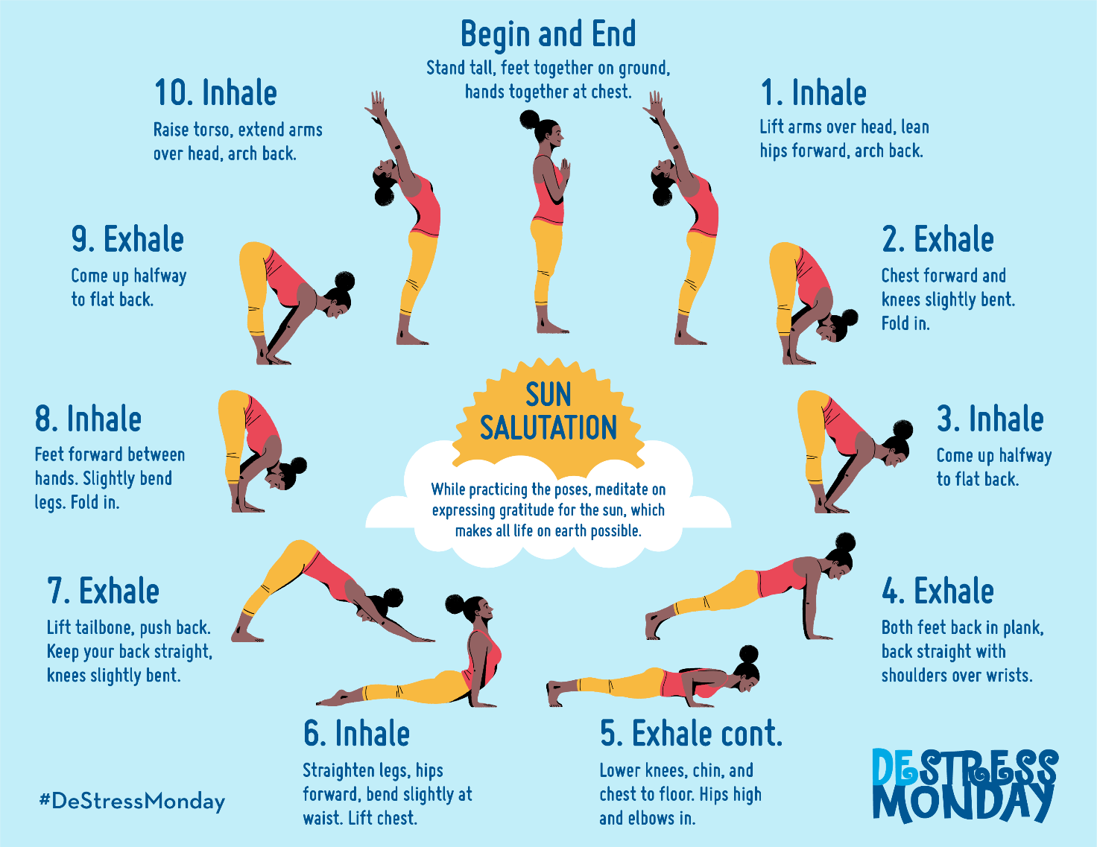

Planets of the Solar System

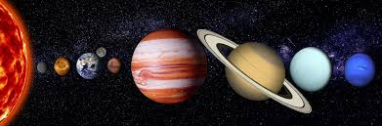
Imagine you are flying into Space in your space ship to explore space and see all the planets. How many would you pass? What are the features of the planets? Can you name the planets in order from nearest to the furthest away from the sun?
Set up 2 cones 20m apart and on the other side, print out and cut out the pictures of all the planets and the sun on the next 2 pages. You can either do this alone or race your sibling or parents.
On go, you will run/race to the other side and grab a planet and run back with it. You will place it at the start and then run back for the next one. You will keep doing this until you have got all of the planets and the Sun. Once you have got them all, you will need to put them in the correct order from the nearest to the sun to the furthest away. See how quickly and accurately you can do this.
Differenciation
Lower Ability: To make this task slightly easier, have a full picture of the solar system at the start so that the children can follow the picture to put the planets in the correct order
Higher Ability: To make the task harder, when they retrieve the planets from the other side, they must retrieve them in order from nearest to furthest (or vice versa). If they do not retrieve them in the correct order, they must return the planet before getting the correct one.
Beat the teacher
Mr Jarad of Primary Sports attempted this challenge and it took him 3 minutes to complete it accurately. Can you beat his time?

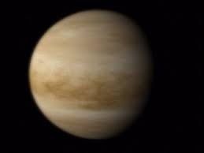

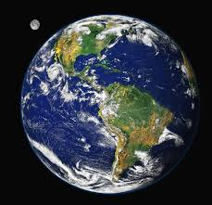
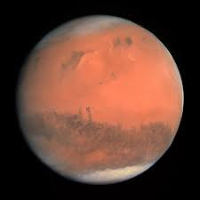

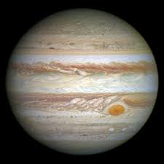
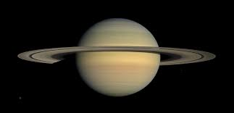

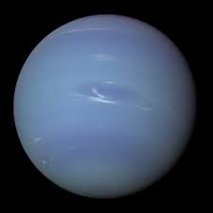

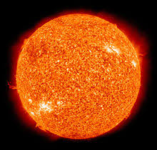

JUMP FOR THE MOON
On Earth, humans experience the effects of gravity as a constant force, pulling on the human body. This constant force is essential for building the healthy, strong bones. Astronauts undergo physical training to ensure their bones are strong enough for their mission. HAVE A GO AT THE ACTIVTIES BELOW
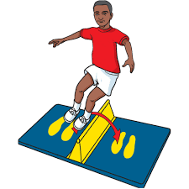
Speed Bounce
Speed Bounce is a two-footed jump in which an athlete must take off and land on both feet. The person should cross the wedge (see image on the right) or similar i.e. cones as many times as possible within 30 seconds. The number of correct bounces is be recorded. It is not an offence to clip or brush the wedge or similar.

Required Resources

Cones/barrier to jump over
Stopwatch
Partner to count

How to conduct the test Performers start on one side of a 20cm foam wedge. The performer has 30 seconds to jump side to side over the wedge as many times as possible.

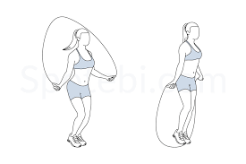
Skipping

- Skip on the spot for 60 seconds without stopping
- Rest for 30 seconds (during this time your partner will tell you how many you did)
- Repeat this activity three times. Did you manage to beat your previous scores?

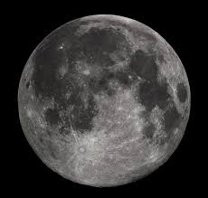
Required Resources

Skipping Rope
Stopwatch
Partner to count
Beat the teacher
Speed bounce
Miss Benedetto of Primary Sports managed to do 54 speed bounces in 30 seconds. Can you beat her score?
Skipping
Mr Jarad of Primary Sports managed to skip 40 times in 60 seconds. Can you beat his score?

Astro Agility Course

Agility is the ability to rapidly change direction without loss of speed, balance or control. Just like an athlete, astronauts must do strength and agility training, to perform better in space and on their return to Earth. Astronauts lose agility while spending time in space because they are floating around and don’t have to change direction quickly.

HAVE A GO AT THE AGILITY COURSE BELOW AND RECORD YOUR BEST SCORE – CAN YOU BEAT A FAMILY MEMBER OR A FRIEND IN YOUR CLASS?

Can you name 5 sports in which you will need to change direction quicky?

Can you provide a scenario in a game situation where you need to be agile?

Astro Agility Course
Procedure
Set up the course as detailed in the diagram below on the left.
Begin by lying face down on the floor at the “Start” cone
The assistant gives the command “GO” and starts the stopwatch.
On Go, jump to your feet and negotiates the course around the cones following the red line route as shown in the diagram to the finish
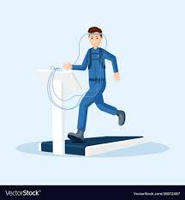
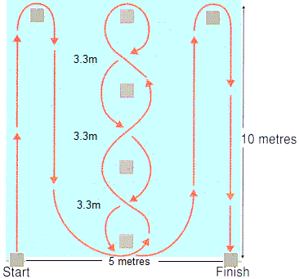
The assistant stops the stopwatch and records the time when the athlete passes the “Finish” cone

Beat the teacher
Miss Benedetto of Primary Sports attempted this challenge. She completed the challenge in 22.8 seconds. Can you beat her time?
PLEASE SEND IN YOUR ANSWERS, PHOTOS AND VIDEOS TO MARCUS@PRIMARY-SPORTS.CO.UK AND WE WILL PROVIDE CERTIFICATES TO THE CHILDREN THAT HAVE COMPLETED THE ACTIVTIES AND CHALLENGES.
On your bike, scooter or Spacehopper

One exercise that has been used by astronauts on the International Space Station for over 10 years is the cycle ergometer (CEVIS). Russian Astronauts have a cycle called VELO. Muscle and bones carry less weigh in weightlessness and get weaker.
What muscle groups are working hard when you cycle?
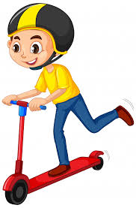
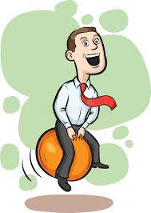
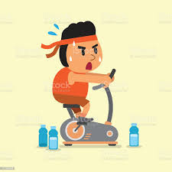
Beat the teacher’s sister!
Mr Jarad’s sister Katie went for a 10-minute ride on an exercise bicycle. She covered 3.51km (2.18 miles). Are you able to ride for longer or cover more distance thank Katie did in 10 minutes?
PLEASE REMAIN AS ACTIVE AS POSSIBLE THROUGHOUT THIS LOCKDOWN
Try to travel as far as they can on static exercise bikes (if you don’t have one, go out for a ride on your normal bike).
Go out for a bounce on a space hopper, or a ride on a scooter.
Record the distance travelled and enter in your exercise diary.
Be encouraged to take pictures of themselves cycling, scooting or space hopping and paste them in their diary.
Mindfulness
When you are exercising, think about the following:
What sounds can you hear? If you’re outside can you hear any birds singing? Or if you’re inside can you hear someone clacking a keyboard or boiling a kettle? Is it cold or warm where you are?

