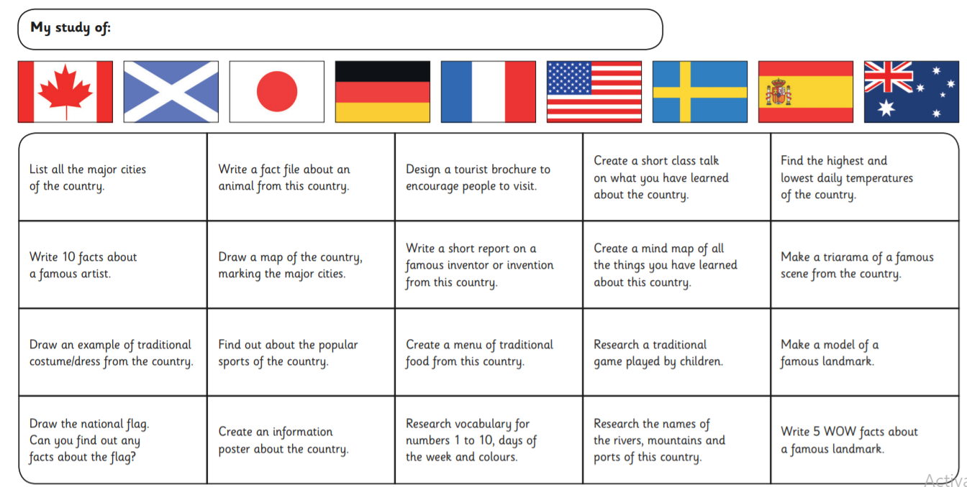

This half term in geography would have been learning about Contrasting localities. Your project for the next **Five** weeks will be to research and compare two countries of your choosing. Below are some ideas for the areas you could investigate in your comparison but of course you may decide to choose your own areas of interest.

I have also included some examples below comparing the UK and India and Scotland and France for your perusal.

You can choose any medium you like to present your work such as powerpoint, poems, models, artwork etc. Be creative!

This is to be handed in on **Monday 22nd February**.

This is to be shared in class on **Monday 22nd February.**